Group Name: Code Addicts

Group Members:

Mehluli Booi – ST10028039

Lesego Ramosa – ST10209476

Lwazi Mesatywa – ST10092086

Scrum Agile Board: <https://trello.com/invite/b/66f3ec71915caa196897689b/ATTIef1728e5d554052d2e321f8c6618193111439D30/code-addicts>

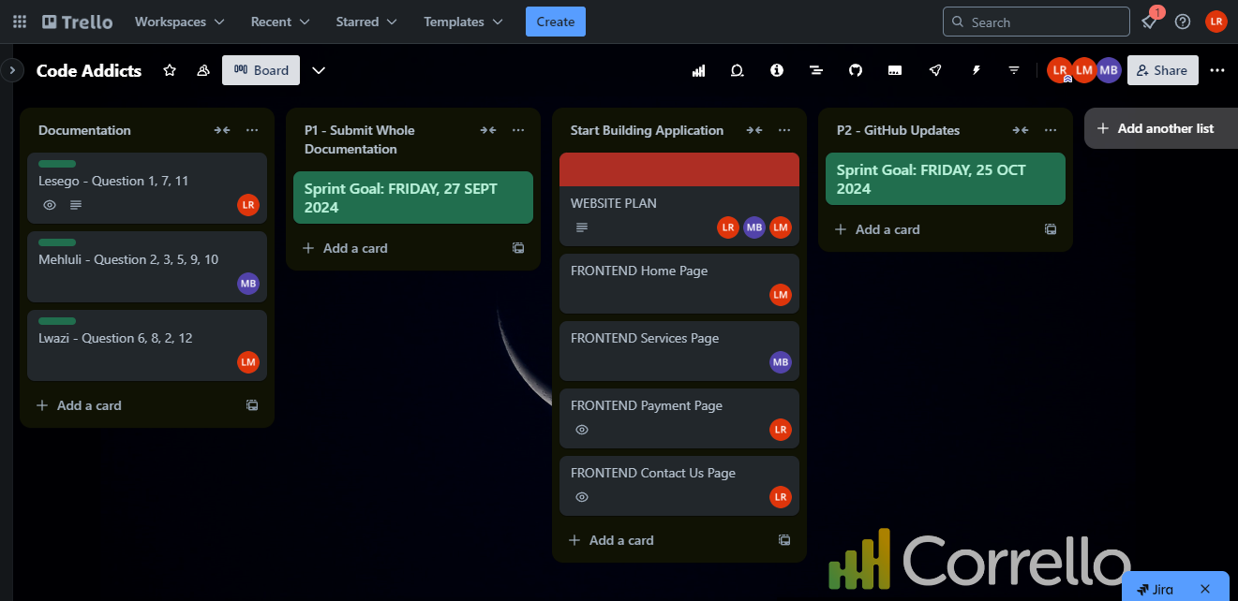

As Code Addicts, we are making use of an agile scrum board namely Trello. In Part 1, we had a sprint goal on Friday, 27 September 2024 and we separated tasks on the documentation amongst each other.

In Part 2, we have a sprint goal on Friday, 25 October 2024 and we planned on how we’re going to build the website making use of Figma. After that we started building the frontend of the pages which were the Home, Services, Payment, and Contact Us.